May 23, 2001 Al Boehnlein Confidential

GDC Alignment procedure, Rev. 2

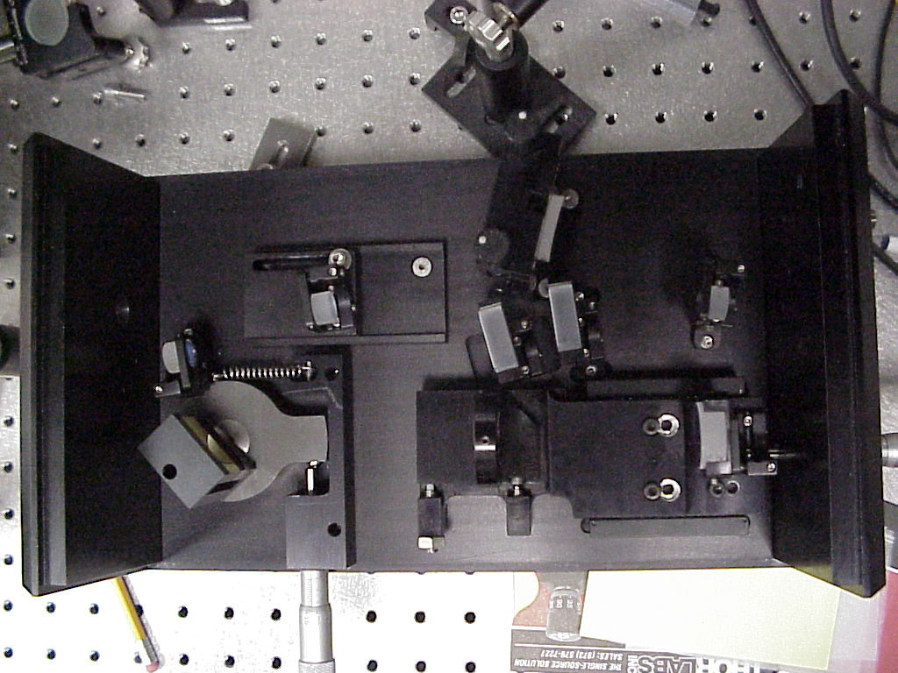

Tools Needed
Allen Wrenches
Tape measure
Optical Fiber Power Meter Level
O’Scope

Hi8 Sony Camcorder and monitor
GDC Alignment Procedure

- Remove M7 to enable better access, be careful not to bump M3.
- Adjust beam to be straight and level and centered through input port and in the center of M1
- Adjust M1 to put beam in center of M2
- Adjust M2 to place beam in corner of M3, as shown in photo 3.
- Adjust M3 to place beam on center of vertical axis of grating, at spot 1. If necessary, use template cut out from last page of this document.
- Adjust grating to center 1st order diffracted beam in vertical center of lens.
- Adjust M4 to place beam on vertical axis of grating, spot 2 of grating template.
- Adjust M3 vertical adjustment to place spot in corner of M5, as illustrated in photo.
- Adjust M5 to put beam on vertical axis of grating at spot 3 of grating photo and in horizontal center of M6. If necessary, use grating template.
- Measure power in and out of GDC, Should get ~50% efficiency between input port and M5.
- Replace M7
- Adjust M6 to place beam in center of M7
- Adjust M7 to center of exit port.
- Place card in GDC
- Hook up laser to fiber.
- Tighten(LIGHTLY) all three tilt/focus screws of the fiber mount to remove lens tilt.
- Use the tri-screw adjustment tool to focus/collimate beam to 1/8” dia.
- Line up two dots on card with the fiber mount with X & Y screws.
- Remove card and hook up fiber to Power Meter.
- Tweak M7 to max power.
- Tweak fiber mount X & Y screws to max power.
- Use the tri-screw adjustment tool to focus/collimate beam to max power.
- Repeat steps 19-21 until no change.
- Walk the beam with M6 and M7 to max power.
- Repeat steps 19-23 until no change.

GDC Alignment procedure
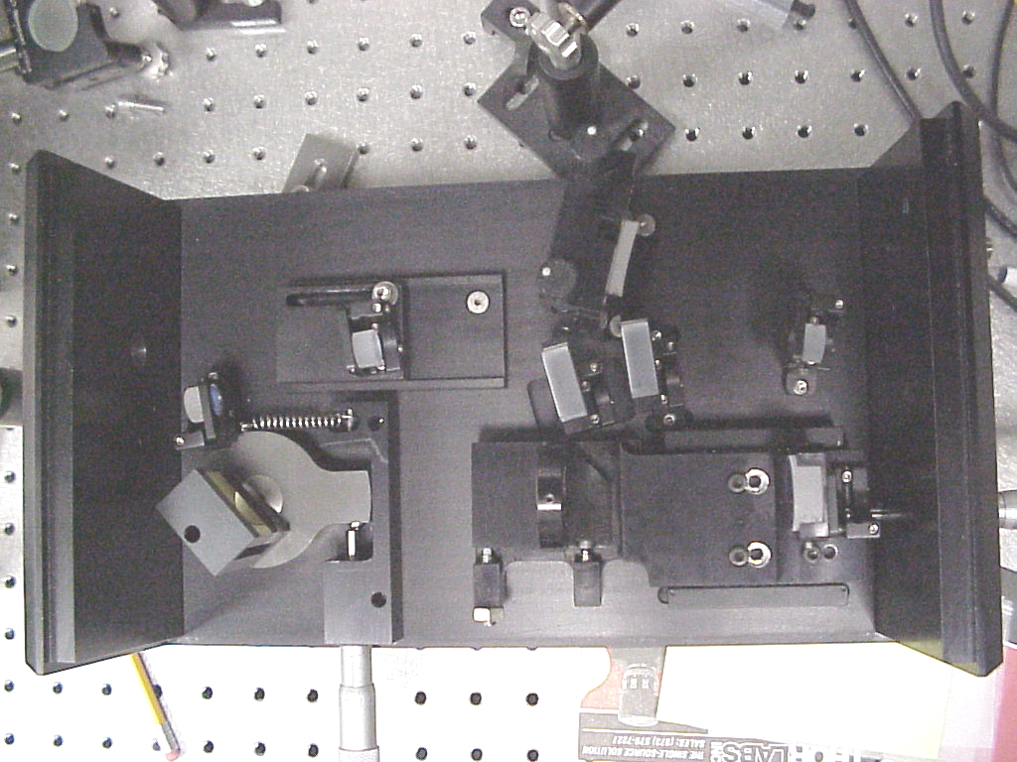
M2
Telescope Mirror
M3
First pass Mirror
M6
First output mirror
L Fourier transform lens
M4 Folding Mirror

G
Grating
1200 l/mm?
M1
Telescope Mirror
M5
Third pass mirror
M7
Second output mirror
Output port
Input port

Photo 1: System layout
Place card here for step 14

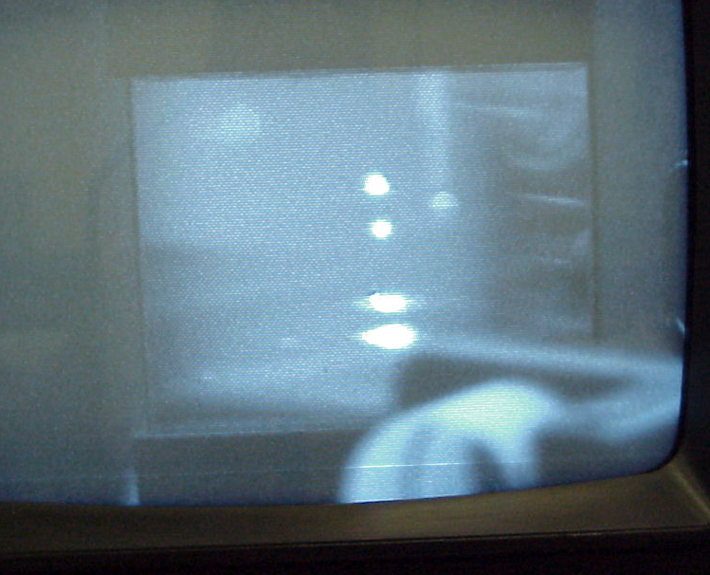
1
2
3
4

Photo 2: Grating Reflections

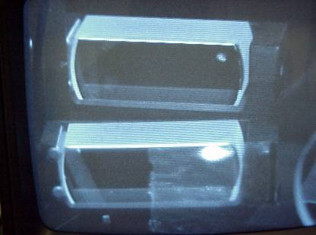

M3
M5

Photo 3: Spot locations on M3 and M5

Grating Template

Caution: Do Not, Under Any Circumstances, Touch Grating
It Can Not Be Cleaned!
Caution: Use low power to avoid burning paper.

Actual size, Cut out on doted line and use as a template.

0.958”
1-M3
2-M4
3-M5
4
Handle
Caution: do not, touch grating, it can not be cleaned. Use low power to avoid burning paper.

